A Project Report

on

STATEWISE IMPACT OF OMICRON

submitted
to

JAWAHARLAL NEHRU TECHNOLOGICAL UNIVERSITY ANANTAPUR

in partial fulfillment of the requirements for the award of the degree of

Bachelor of Technology
in
Computer Science and Engineering(Data Science)

by
M VINAY KUMAR
(22FH1A3239)

Under the esteemed guidance of

Dr. B.Mahesh, _{M.Tech.,} _{Ph.D}
Associate Professor



DEPARTMENT OF COMPUTER SCIENCE & ENGINEERING(DS)

Dr. K. V. SUBBA REDDY INSTITUTE OF TECHNOLOGY

(Autonomous)
(Approved by AICTE, NEW DELHI, Accredited by NAAC A+ & Affiliated to JNTUA, Anantapur )
An ISO 9001:2000 Certified Institution
OPP.DUPADU (RS), NH-44, LAKSHMIPURAM (PO), KURNOOL-518218.
2022-2026

STUDENT DECLARATION

I, M VINAY KUMAR bearing the Roll Number 22FH1A3239, here by declare that this Project entitled “STATEWISE IMPACT OF OMICRON”

done by me under the guidance of Dr.B.Mahesh, AssociateProfessor, Department of CSE, and this work is not copied and submitted anywhere for the award of any degree.

Date:
Place: Kurnool
(M VINAY KUMAR)

GUIDE DECLARATION

I hereby declare that this project entitled “STATEWISE IMPACT OF OMICRON” done by M VINAY KUMAR bearing Roll Number 22FH1A3239 under the guidance of me.

Date:
Place: Kurnool

Dr.B.Mahesh
AssociateProfessor,
Department of CSE

Ph.08518-287670 Fax: 08518-287618
Dr. K.V. SUBBA REDDY INSTITUTE OF TECHNOLOGY (Autonomous)
An Engineering College Sponsored by
Vaibhav Educational Society, Kurnool
Approved by AICTE, New Delhi and Affiliated to JNTUA, Anantapur
Opp.Dupadu (RS) ,N.H-44,Kurnool -518218,Kurnool District, A.P.
www.drkvsrit.in

DEPARTMENT OF COMPUTER SCIENCE & ENGINEERING(DS)
BONAFIDE CERTIFICATE
Certified that this thesis report titled “STATEWISE IMPACT OF OMICRON” is the bonafide work of M VINAY KUMAR bearing Roll No. 22FH1A3239 who carried out the research under my supervision. Certified further, that to the best of my knowledge the work reported herein does not form part of any other project report or dissertation on the basis of which a degree or award was conferred on an earlier occasion on this or any other candidate.

Signature of Guide Signature of Project
Coordinator/HOD

Signature of Internal Examiner Signature of External Examiner

ACKNOWLEDGEMENTS

It is my privilege and pleasure to express my profound sense of respect, gratitude and indebtedness to my guide, Dr.B.Mahesh, _{M.Tech}., _{Ph.D}, Associate Professor, Department of Computer Science and Engineering(DS), Dr. K.V. Subba Reddy Institute of Technology, Kurnool., for his indefatigable inspiration, guidance, cogent discussion and encouragement throughout this dissertation work.

I am grateful to Dr. M.Veeresha, _{M.Tech, Ph.D ,} Head of the Department of DS & AIML for his support and uninterrupted cooperation during my project work.

I am deeply indebted to my Principal Dr. J. Kanna Kumar, _{M.Tech, Ph.D} for his constant support and valuable guidance was a source of inspiration for me.

This Acknowledgement will be incomplete without mentioning my sincere gratefulness to our honorable Chairman Dr. K.V. Subba Reddy Garu, who has been observed posing valiance in abundance, forwarding my individuality to acknowledge my project work tendentiously.

Last but not least, I wish to acknowledge my friends, family members and colleagues for giving moral strength and helping me to complete this dissertation.

(M VINAY KUMAR)

TABLE OF CONTENTS
Sr. No. | Topic | Page No.
1 | DATA VISUALIZATION
2 | TYPES OF DATA VISUALIZATION
3 | DATA VISUALIZATION WORKING
4 | HOW TO WORK ON TABLEAU BY USING CSV FILES
5 | IMPLEMENTATION
6 | CONCLUSION

Data Visualization
Data visualization is the graphical representation of data and information using visual elements such as charts, graphs, maps, and dashboards. The goal is to make complex data more accessible, understandable, and usable. Common types of data visualizations include:
- Bar Charts & Column Charts – Compare categories or groups
- Line Charts – Show trends over time
- Pie Charts – Display proportions within a whole
- Scatter Plots – Show relationships between two variables
- Heatmaps – Represent data density or intensity
- Dashboards – Combine multiple visualizations for insights
Data visualization is the practice of translating data into graphical or pictorial formats to make information easier to interpret. It helps in identifying patterns, trends, and insights that might not be obvious in raw data.
Purpose of Data Visualization:
- Simplifies complex data
- Enhances decision-making
- Identifies trends and patterns
- Makes comparisons easier
- Communicates insights effectively

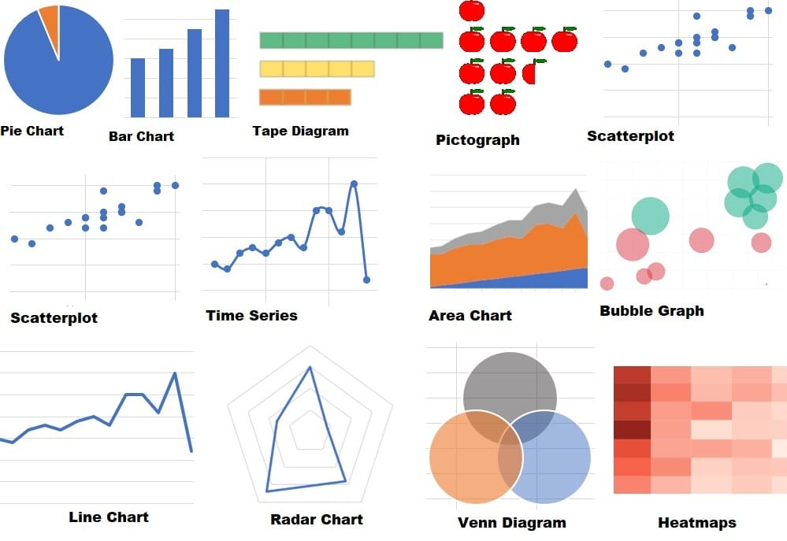

Types of Data Visualization

1. Categorical Data Visualizations (For Comparing Categories)
📊 Bar Chart – Compares data across different categories.
📏 Column Chart – Similar to bar charts but vertical.
📍 Stacked Bar Chart – Shows parts of a whole while comparing across groups.
🎯 Pie Chart – Displays proportions in a circular format.
🌀 Donut Chart – A variation of a pie chart with a hollow center.

2. Time-Series Visualizations (For Showing Trends Over Time)
📈 Line Chart – Tracks changes over time (e.g., stock prices).
📊 Area Chart – Similar to a line chart but with filled areas to show volume.
🔄 Timeline Chart – Shows events over time (e.g., project phases).
📆 Calendar Heatmap – Displays patterns by day, week, or month (e.g., website visits).

3. Relationship Visualizations (For Showing Correlations)
🔵 Scatter Plot – Displays relationships between two variables.
🟢 Bubble Chart – Like scatter plots but with varying bubble sizes to represent a third variable.
🔗 Network Graph – Shows connections between elements (e.g., social networks).

4. Distribution Visualizations (For Understanding Data Spread)
📊 Histogram – Displays data distribution in bins (e.g., test scores).
📏 Box Plot (Box-and-Whisker Plot) – Summarizes data spread with quartiles.
🔥 Violin Plot – Similar to a box plot but with density distribution.

5. Hierarchical Visualizations (For Showing Levels of Data)
🌲 Tree Map – Uses nested rectangles to show hierarchy.
🔽 Sunburst Chart – A radial version of a tree map.
📂 Dendrogram – Shows hierarchical clustering (e.g., genetic trees).

6. Geospatial Visualizations (For Location-Based Data)
🗺️ Choropleth Map – Uses different colors to show density per region.
📍 Dot Map – Uses dots to represent data points (e.g., population density).
📊 Heatmap – Shows intensity of data values on a geographic map.
🛣️ Flow Map – Represents movement between locations (e.g., migration patterns).

7. Text-Based Visualizations (For Analyzing Words & Text)
🔤 Word Cloud – Displays word frequency using font size.
📄 Text Network Graph – Shows relationships between words.
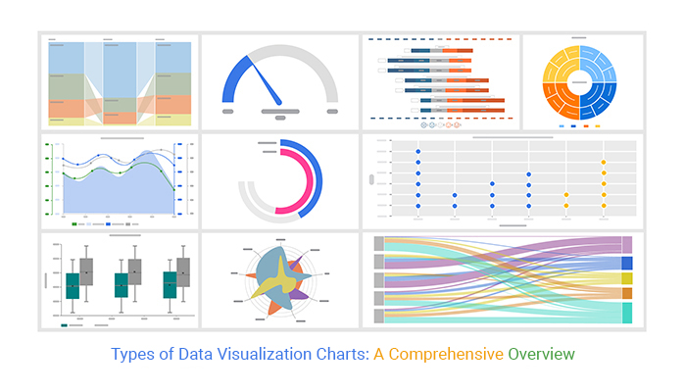

Data Visualization working
- How is Data Visualization ?
Data visualization is a structured process that involves collecting, processing, and representing data in a visual format. Here’s how it’s typically done:

1. Data Collection
Before visualizing data, you need to gather relevant information from various sources, such as:
✅ Databases (SQL, NoSQL)
✅ APIs (social media, financial markets)
✅ Spreadsheets (Excel, Google Sheets)
✅ Real-time IoT sensors

2. Data Cleaning & Preparation
Raw data is often messy and needs to be cleaned before visualization. This involves:
✔️ Removing duplicates & errors
✔️ Handling missing values
✔️ Converting data types (e.g., date formats)
✔️ Normalizing & scaling data

3. Choosing the Right Visualization Type
The choice of visualization depends on the type of data and the insights needed:
✔️ Comparisons → Bar charts, pie charts
✔️ Trends over time → Line charts, area charts
✔️ Relationships between variables → Scatter plots, bubble charts
✔️ Geospatial data → Maps (choropleth, heatmaps)
✔️ Hierarchical data → Tree maps, sunburst charts

4. Using Visualization Tools
There are many tools available for creating data visualizations, including:
📌 Beginner-Friendly Tools:
- Excel / Google Sheets (basic charts)
- Tableau (drag-and-drop dashboards)
- Google Data Studio (interactive reports)
📌 Advanced Tools:
- Python (Matplotlib, Seaborn, Plotly)
- R (ggplot2, Shiny)
- Power BI (Microsoft’s business analytics tool)
- D3.js (JavaScript-based data visualization)

5. Customizing & Enhancing the Visuals
To make data visuals more effective:
✔️ Use contrasting colors to highlight key points
✔️ Add labels & annotations for clarity
✔️ Avoid clutter (too many elements confuse the viewer)
✔️ Maintain a logical flow

6. Sharing & Interpreting the Visuals
Once the visualization is ready, it can be:
📊 Embedded in reports or dashboards
📈 Presented in meetings
🌐 Published on websites or blogs
💻 Used for data-driven decision-making
- Why is Data Visualization Important in Presentations?
Data visualization plays a crucial role in presentations because it transforms complex information into clear, engaging, and persuasive insights. Here’s why it’s essential:

1. Simplifies Complex Data
Presenting raw numbers or spreadsheets can be overwhelming. Charts, graphs, and infographics make the data easy to understand.
📌 Example: Instead of listing sales figures in a table, a bar chart can instantly show which months had the highest revenue.

2. Engages the Audience
People process visual information faster than text and are more likely to stay engaged when data is presented visually.
📌 Example: A heatmap of customer activity is far more interesting than reading through a long report.

3. Highlights Key Insights Quickly
Good visualizations help the audience grasp key trends, comparisons, or anomalies within seconds.
📌 Example: A line chart in a financial presentation can instantly reveal a company’s growth over time.

4. Supports Storytelling & Decision-Making
Data storytelling is more effective when visuals reinforce the message. A well-placed chart or graph can persuade stakeholders and guide decision-making.
📌 Example: A pie chart showing market share can convince investors why a company is outperforming competitors.

5. Increases Memorability
People remember visuals better than text. A compelling data visualization can leave a lasting impression.
📌 Example: A before-and-after comparison using infographics can make a business impact more memorable.

6. Enhances Credibility & Persuasion
A well-designed visualization backed by real data builds trust with the audience.
📌 Example: A CEO presenting customer satisfaction improvements using real survey data builds credibility.

7. Saves Time & Improves Efficiency
Instead of explaining numbers for minutes, a single well-designed chart can communicate everything instantly.
📌 Example: A project timeline with a Gantt chart helps teams quickly see deadlines and priorities.

8. Helps Identify & Explain Trends
Trends and patterns are easier to spot when data is visualized.
📌 Example: A stock market performance chart helps analysts see market trends over time.

Conclusion: Why You Need Data Visualization in Presentations
✔ Makes data simple & understandable
✔ Keeps the audience engaged
✔ Highlights key insights instantly
✔ Enhances storytelling & persuasion
✔ Boosts credibility & trust

- HOW TO WORK ON TABLEAU BY USING CSV FILES

1. Define the Objective
- Purpose: Clearly articulate what you want to achieve with your visualization. Are you trying to show trends over time, compare
- tegories, or highlight specific data points?
- Audience: Understand who will be viewing the visualization. Tailor the complexity and detail of the visualization to their level of expertise.

2. Connect to Data
- Open Tableau: Launch Tableau Desktop or Tableau Public.
- Connect to Data Source:
  - Click on "Connect" in the start screen.
  - Choose your data source type (Excel, Text file, Database, etc.).
  - Navigate to your file or database and establish the connection.
- Data Preview: Review the data in Tableau’s data source tab to ensure it has been imported correctly.

3. Data Preparation
Data Cleaning:
  - Remove unnecessary columns or rows.
  - Handle null values by filtering them out or replacing them with appropriate values.
Data Transformation:
  - Calculated Fields: Create new fields based on existing data (e.g., profit margin).
  - Data Types: Ensure that fields are set to the correct data types (e.g., date, string,number).
  - Pivoting: If your data is in a wide format, you may need to pivot it to a long format for better analysis.

4. Choose the Right Visualization Type
Drag and Drop:
  - Drag dimensions (categorical data) to the Rows or Columns shelves.
  - Drag measures (numerical data) to the opposite shelf.
Visualization Suggestions:
Tableau will suggest visualization types based on the data you select. You can also manually choose from the "Show Me" panel.
Common Visualization Types:
  - Bar Charts: Good for comparing quantities across categories.
  - Line Graphs: Ideal for showing trends over time.
  - Pie Charts: Useful for displaying proportions of a whole.
  - Scatter Plots: Great for showing relationships between two variables.
  - Heatmaps: Effective for visualizing data density or intensity.

5. Customize the Visualization
Formatting:
  - Use the Format pane to adjust colors, fonts, and borders.
  - Set a consistent color scheme that aligns with your brand or theme.
Labels and Titles:
  - Add titles to your visualizations for context.
  - Use data labels to show exact values on the chart.
Filters:
  - Drag fields to the Filters shelf to limit the data displayed.
  - Create filter actions to allow users to interactively filter data.

6. Create Dashboards
- New Dashboard: Click on the "New Dashboard" button at the bottom of the Tableau interface.
- Drag Visualizations: Drag your individual sheets onto the dashboard canvas.
- Layout Containers: Use horizontal or vertical containers to organize your visualizations neatly.
- Dashboard Actions: Add interactivity by creating actions that allow users to filter or highlight data across multiple visualizations.

7. Add Interactivity
- Filter Actions: Allow users to click on a visualization to filter other visualizations on the dashboard.
- Highlight Actions: Enable users to hover over data points to highlight related data.
- URL Actions: Link to external resources or additional information.

8. Publish and Share
Publishing:
  - Publish your workbook to Tableau Server or Tableau Online for sharing within your organization.
  - Use Tableau Public to share visualizations with a broader audience.
Export Options:
  - Export visualizations as images (PNG, JPEG) or PDFs for reports.
  - Share links to your published dashboards.

9. Gather Feedback and Iterate
- User Feedback: Collect feedback from users to understand their experience and insights.
- Adjustments: Make necessary changes based on feedback to improve clarity, usability, and effectiveness.

10. Document the Process

Documentation: Keep a record of:
  - Data sources and any transformations applied.
  - Calculated fields and their purposes.
  - Design choices and rationale for visualizations.
- Future Reference: This documentation will be helpful for future projects or for onboarding new team members.

Additional Tips
- Use Tooltips: Customize tooltips to provide additional context when users hover over data points.
- Performance Optimization: For large datasets, consider using extracts instead of live connections to improve performance.
- Stay Updated: Keep up with Tableau updates and new features to enhance your visualizations.

IMPLEMENTATION
About the Dataset
The dataset for this project was sourced from Kaggle and contains real-world COVID-19 data.
It includes information on confirmed cases, deaths, recoveries, and daily trends across various states in India.
The dataset was cleaned, pre-processed, and analyzed to create meaningful visualizations that help understand the impact of the pandemic.

Data source connection
First connect the statewise omicron dataset to tableau and select the statewise sheet.
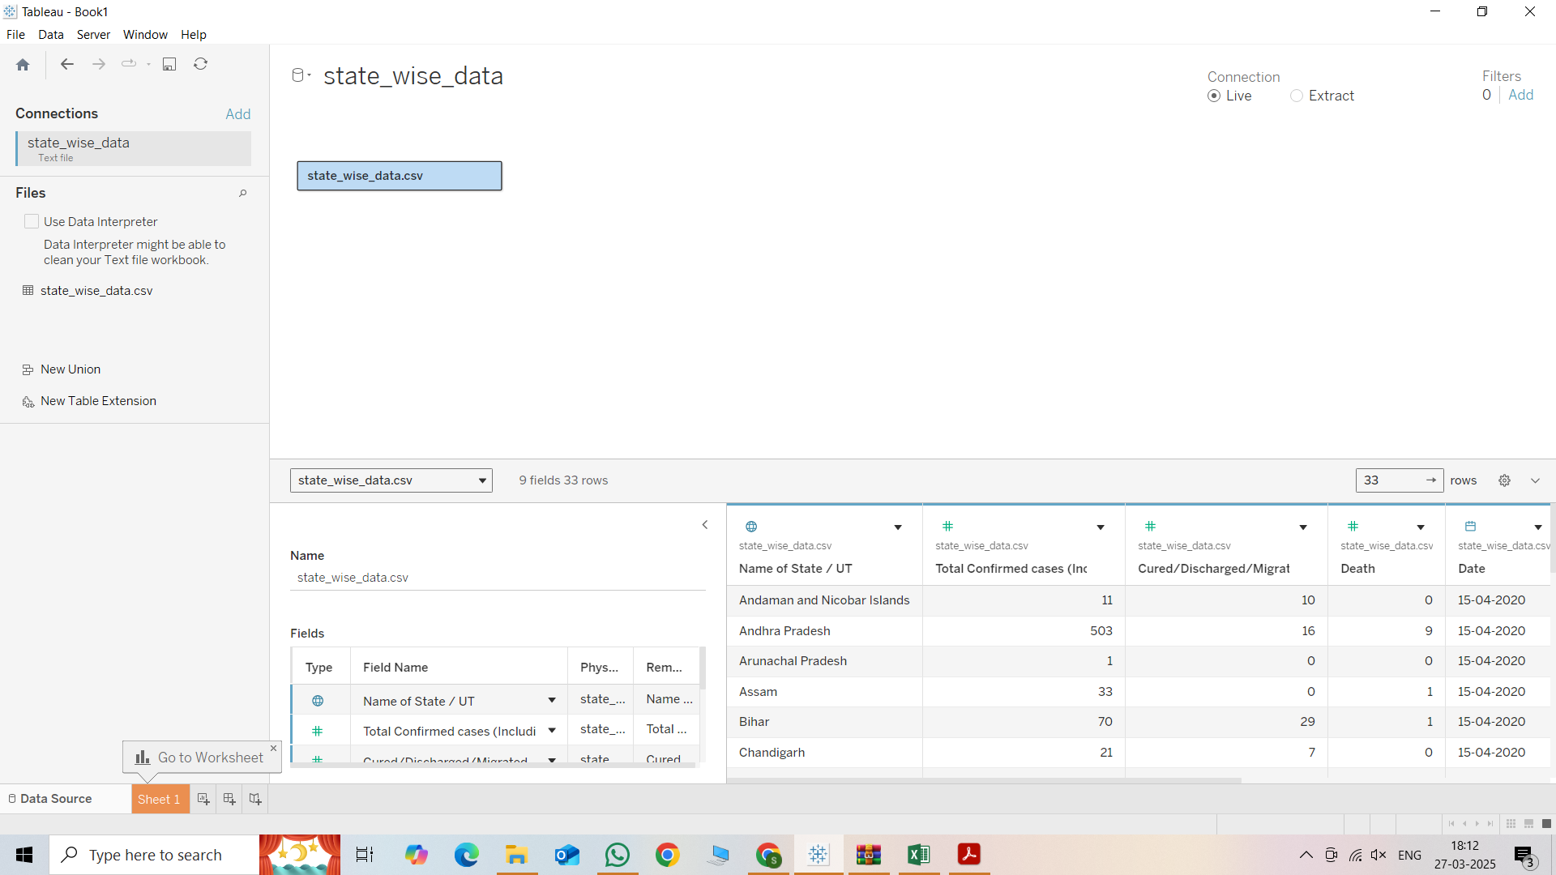

Create First Tableau worksheet
Now go to sheet 1 and start creating the first graph as explained in the 3rd point of business requirement. Here you can use “measure values” and “measure names” to accomplish this. Once done, make a little decoration and you should get something like below

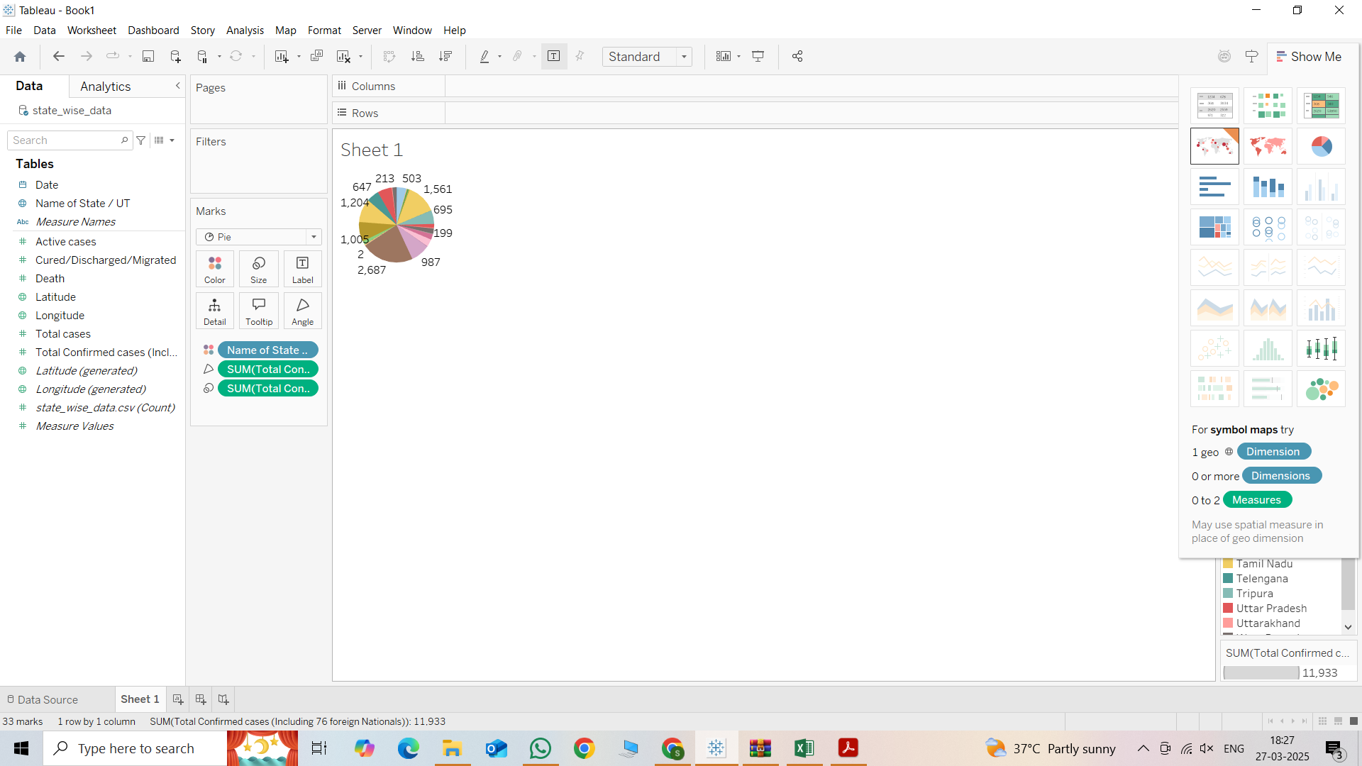

- Go to sheet 2
- Drag “YEAR” (DATE) to the columns shelf.
- Drag “Name of state/UT “ to the columns shelf(after Date).
- Drag “SUM(Total Cases”) ,”SUM(Active Cases)”,SUM(Recovered Cases)”,and “SUM(Deaths)’ to the rows shelf.
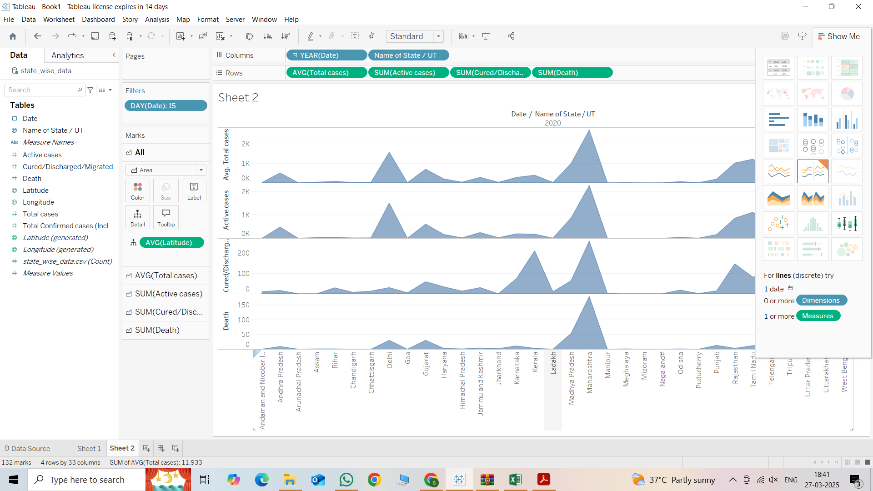

- Create a sheet 3
- Drag “Name of State/UT “to the rows shelf.
- Drag “SUM(Total cases)” to the columns shelf.
- From the marks section, select “Bar Chart” for clear visualization.
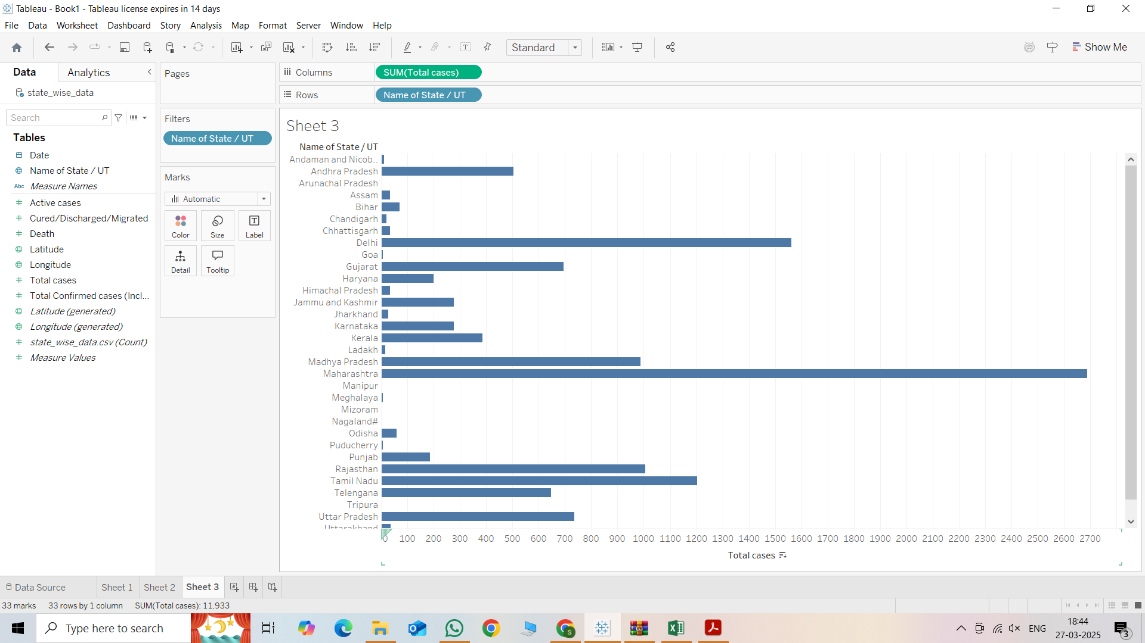

- Create sheet 4

- Drag “Name of state/UT “ to Rows.
- Drag “Year(Date)” to the columns.
- Drag “SUM (CURED/DISCHARGED)” to size and color(for intensity).
- Choose “Treemap” from the marks dropdown.
- Enhance visualization by labeling.

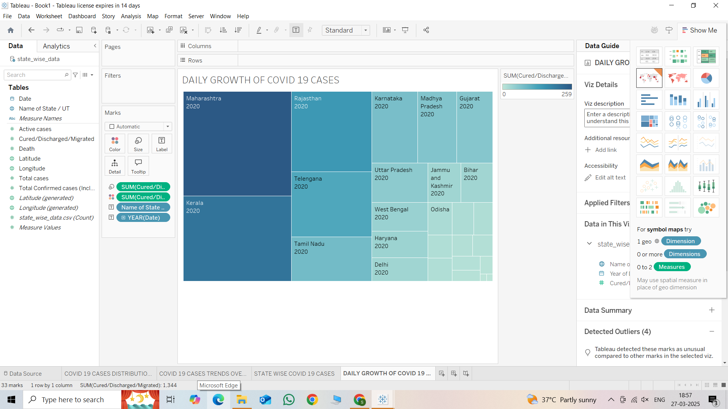

- Create sheet 5
- Drag “Name of State/UT “to the rows shelf.
- Drag “ Sum(cured/discharged)” to the columns shelf.
- In the marks section , select “Pie” as the chart type.
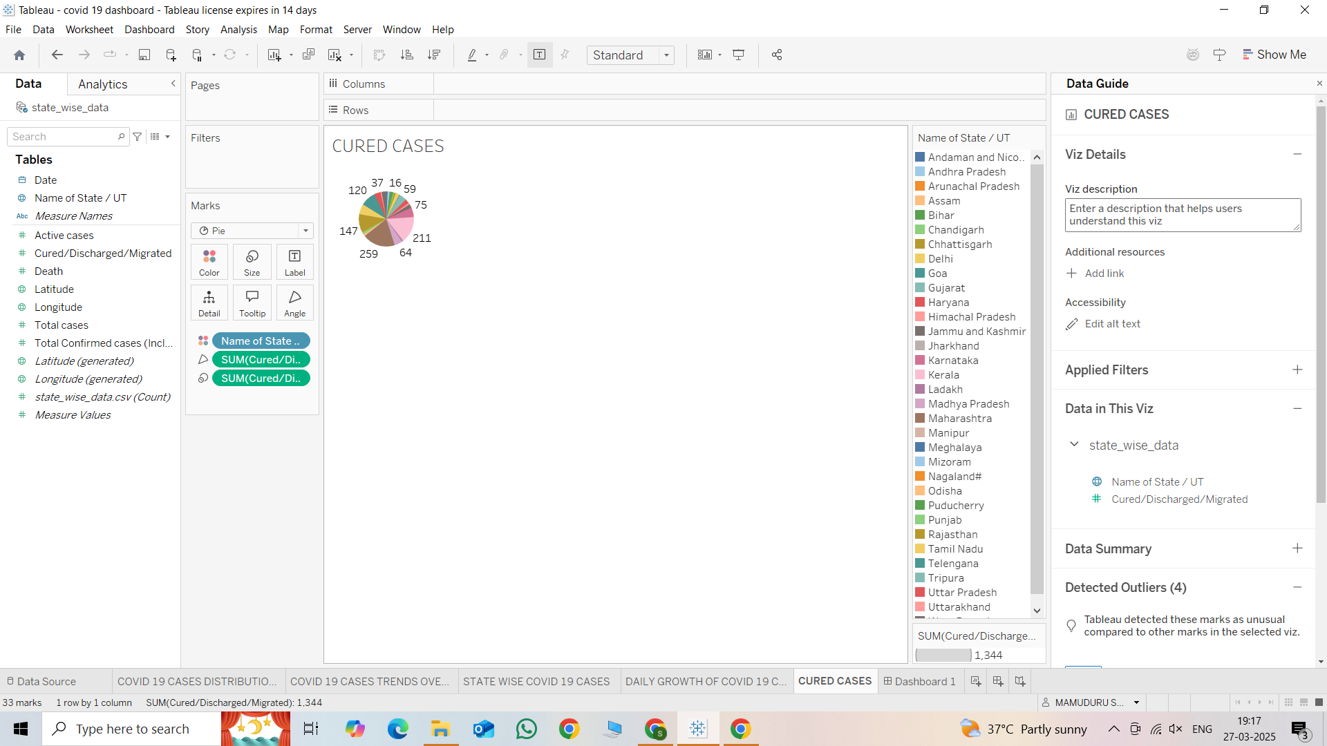

Add Filters in Tableau
- Drag “DAY(Date) “ to the filters shelf to allow date-based filtering.
- Drag “State/UT Name” to filters to analyze specific states.
- Filter by Date
- Format labels & colors
- Sort states by recovery rate
- Add date filter for data analysis & adjust color gradient for better clarity.

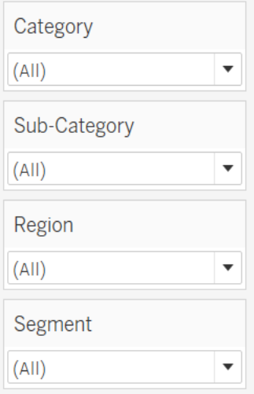

DASHBOARD CREATION:
- Click on “New dashboard ”at the bottom.
- Drag and drop the required sheets (charts/graphs) onto the dashboard.
- Adjust the layout using Tiled or Floating mode.
- Click on a char-> Select “Use as Filter” to make it interactive.
- Add a title , text ,and formatting for clarity.
- Save and share the dashboard.

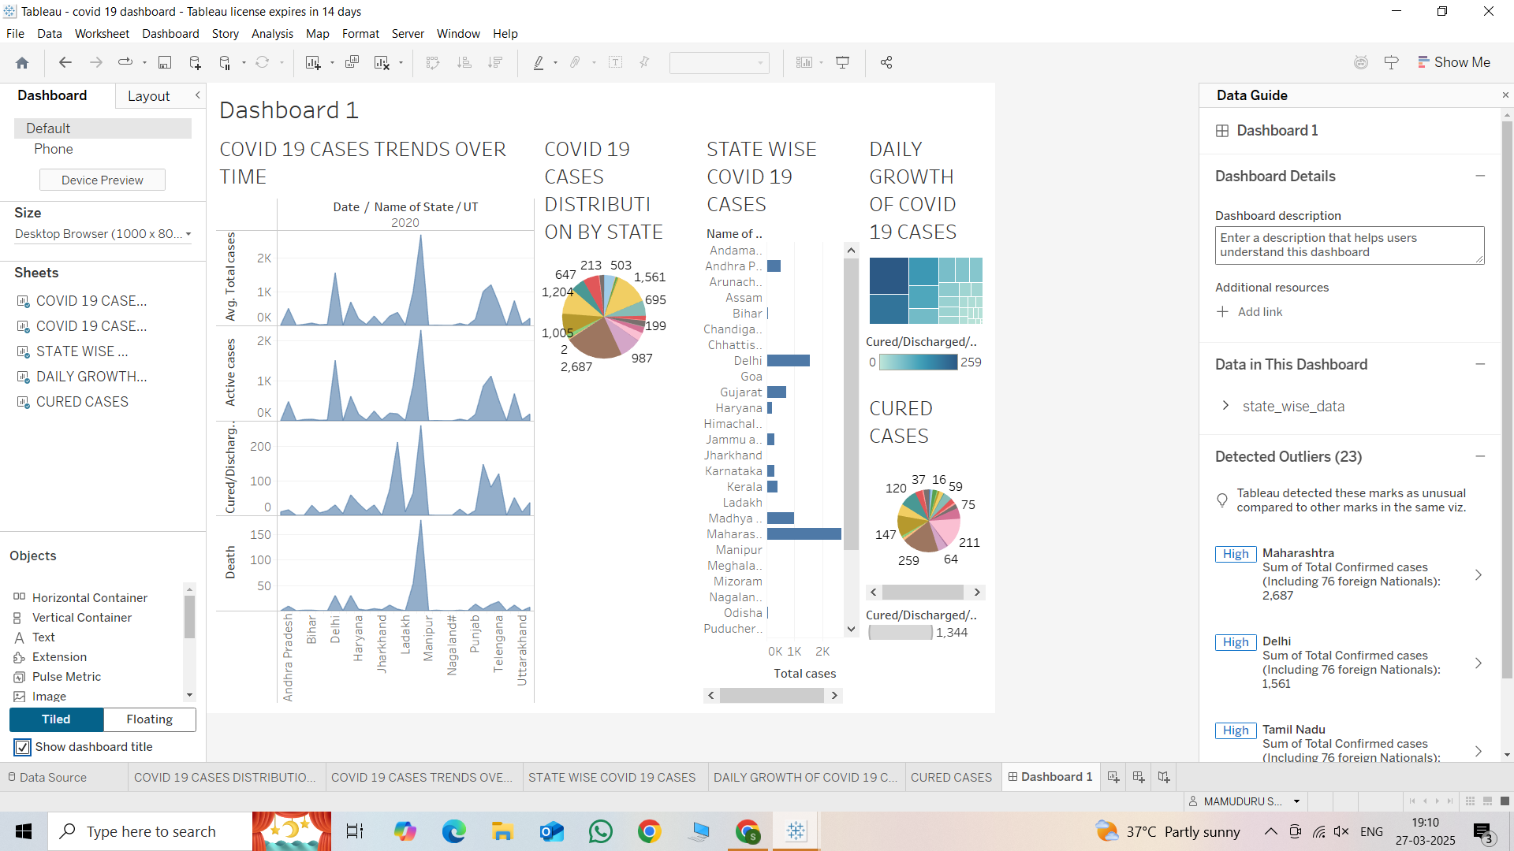

Results & Insights
- Maharashtra reported the highest number of cases, followed by Delhi and Tamil Nadu.
- Recovery rates varied across states, affecting healthcare strategies.
- Urban areas had significantly higher infection rates, indicating the need for targeted containment measures.
- Interactive Tableau visualizations allow deeper exploration of trends over time.

Conclusion & Future Scope
This project successfully visualized the impact of omicron using Tableau. The findings help in understanding how the pandemic spread across states and the effectiveness of different containment strategies.
Future enhancements could include:
1. Integration of real-time data updates.
2. Advanced predictive modeling to forecast future trends.
3. Enhanced geographic analysis using Tableau Maps
GITHUB LINK:

